2019 Global Culture Ambassador Competition

INTRODUCTION

With 41 University-based Mandarin Learning Center located around the nation—Taiwan—the Mandarin learning hub, attracts more than 75,000 foreign students worldwide. As an advocate and pioneer of creative education in Taiwan, Quanta Culture and Education Foundation (QCEF) sees the endless possibilities of cultural exchange between the foreign and the local students.
With the goal of providing an interactive and didactic culture exchange platform, Quanta Culture and Education Foundation hosts an annual competition, called the Global Culture Ambassador Competition. This competition selects 10 foreign college students as the Culture Ambassador Candidates, who take on the roles as the culture ambassadors representing their own countries. By pairing them with 10 Quanta Partner Schools located around Taiwan, foreign students are given the opportunity to develop practical Mandarin skills, grow an in-depth understanding of Taiwan, and share their hometown culture. Meanwhile, teachers and students in Taiwan have the chance to experience a foreign culture without traveling abroad, and learn to view Taiwan and the world from a dual perspective.
At the end, QCEF will announce the winner of the “2019 Global Culture Ambassador” amongst the 10 Culture Ambassador Candidates.

OBJECTIVE
Foreign students in Taiwan:
1. Opportunity to develop practical Mandarin skills
2. In-depth understanding of Taiwan
3. Share personal perspective of their own culture
4. Opportunity of international volunteering
5. Practical experience of culture exchange
University, high school and elementary school in Taiwan:
1. Learn to view Taiwan and the world from another perspective
2. Gain knowledge beyond classroom
3. Experience of communicating and sharing
4. Enhance local-identification
5. Expand worldwide perspective

ORGANIZED BY: Quanta Culture and Education Foundation(QCEF)
CO-ORGANIZED BY: International Cooperation and Development Fund (TaiwanICDF)

APPLICANT’S ELIGIBILITY AND PARTICIPANTS
- Foreign Students:
  - Studying at universities or colleges in Taiwan
(Include degree, exchange, and Mandarin students; exclude overseas Chinese and native speakers of Chinese).
  - Taiwan VISA valid until Feb. 28th, 2020
- Applicant Counselor:
  - Each applicant is encouraged to seek help from a school counselor (limited to Taiwanese residence) during the application process.
  - The counselors of the 10 Candidates will be rewarded with NT$5,000.
- Quanta Partner Schools:
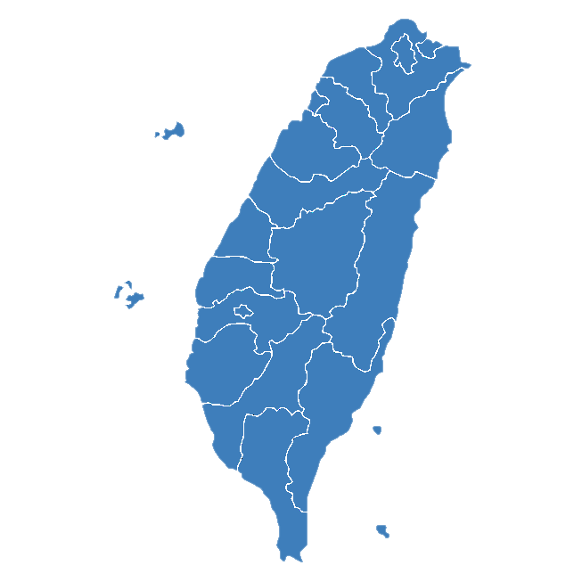
  - Partner Schools are selected for geographic dispersal to offer candidates the best opportunities to explore different parts of Taiwan and embrace a wider variety of Taiwanese Culture. These schools have also been selected for their solid relationship with QCEF to ensure reliability and support (see attached for Partner School’s Cultural Mission).
Hualian County
Hua Gang Junior High
Yilan County
Shin Sheng Elementary
APPLY ONLINE
Scan QRcode to apply
Keelung City
National Keelung Senior High
Kaohsiung City
Fu Shan Elementary

Taidong County
Lyu Dao Junior High
Taichung City
Li Ren Elementary
Changhua County Hu Dong Elementary
Nantou County
Sin Cheng Elementary
Hsinchu County
Jhu Dong Elementary
Miaoli County
Cheng Gong Elementary
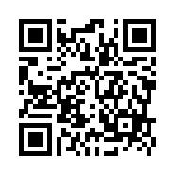
- Fill in basic information.
- Rank the Partner School in order of preference based on the Cultural Mission of each Partner School.
- Upload a Self-Introduction Video in Mandarin (Including a Cultural Mission idea corresponding to your first choice of the Partner School.)
- Upload a copy of your Taiwan Visa (Valid until Feb. 28th, 2020), Proof of Enrollment Letter
- Note: Each applicant is encouraged to seek help from a school counselor (limited to Taiwanese residence) during the application process.
- Deadline: 10/14/2019.

SCREENING & SELECTION
- 10 Culture Ambassador Candidates Selection: Among all the applicants, QCEF will select 10 Candidates based on personal information, self-introduction video, and the Cultural Mission plan. Each Candidate will be paired with one Partner School, and together complete the Cultural Mission that both parties agreed.
- Screening Criteria:
Criteria | Proportion | Details
Mandarin Literacy | 40% | Communicate Fluently in Mandarin
Cultural Mission Plan | 40% | Clearly list out the Cultural Mission goal, content, and execution plan
Overall Performance | 20% | Overall presentation, attitude, personality

- Announcement of the 10 Candidates and their paired Partner Schools on QCEF official website: 10/27/2019
- Candidate Orientation: 11/2/2019; Location: Quanta Culture and Education Foundation Office in Taipei.
- Important Note: The final Cultural Mission will not be the same as the Candidate’s original proposal since the Candidate and the Partner School will discuss the final Cultural Mission once they are paired. Candidates who are unable to participate in the Orientation will be replaced by the alternates.

CULTURAL MISSION
- The 10 Culture Ambassador Candidates should coordinate with their assigned Partner School’s contact window as soon as possible to arrange the travel plans, dates, space, Venue, etc.
- Cultural Mission Planning with Partner School: 10/27/2019 － 11/13/2019
- Cultural Mission Execution Proposal: Before 11/13/2019
- Cultural Mission Execution Date: 11/18/2019－12/20/2019
- Cultural Mission Execution Guideline:
  - Candidates MUST pay at least 2 visits and keep an accurate record of their Cultural Mission execution, including documents, photographs or other means. At the end, the Candidates and the Partner Schools are required to arrange a forum to examine the differences between Taiwanese and foreign education, and each composes an analysis the Evaluation Report.
  - Candidates must share on QCEF Facebook’s page, containing photos and an account of their experiences during execution, in both Mandarin and hometown language as a way to promote Taiwan to the world. Where possible, posts should be made in their personal Facebook pages, choose “Public” for posting privacy, and link it to the 2019 Global Culture Ambassador Facebook page (during 11/18-12/30/2019).

FINAL JUDGING
- Winner Selection: A panel of judges will take into account of the Candidate’s self-evaluation report (60%) and the report from the Partner School (40%) to select the winner of 2019 Global Culture Ambassador from the 10 Candidates.
- Candidate’s Self- Evaluation Report (see attached) Submission Deadline: 12/30/2019
- Judging Period: 1/3-1/10/ 2020
- Judging Criteria

Criteria | Proportion
Cultural Mission Execution (based on the Evaluation Reports) | 30%
Planning and Execution Ability | 30%
Impact | 20%
Creativity | 10%
Mandarin Literacy | 10%

- Announcement of the Final Result: 1/14/2020
- Award Ceremony: 1/22/2020; Location: Taipei (Venue will be announced)

AWARD
- Culture Ambassador Candidates: Certificate and Execution Fee NT$15,000
- Culture Ambassador Candidate’s Counselor: Certificate and Counseling Award NT $5,000
- Culture Ambassador Candidate’s Partner School: Certificate and Assistance Execution Fee NT$10,000
- 2019 Global Culture Ambassador: Certificate and NT$10,000 Taiwan Travel Voucher.
- 2019 Global Culture Ambassador’s Partner School: Round-trip airfare to Ambassador’s home country (limited to NT$50,000).
- Best Execution, Most Creative, and Best Promotion Award. Each award comes with a certificate and a gift.

CONTACT

- QCEF
Said Kuo
(02) 2882-1612 #66698
Said.Kuo@quantatw.com

- TaiwanICDF
Ming-Ying Cai
(02)2873-2323#603
m.y.cai@icdf.org.tw

Quanta Culture & Education Foundation
9F. #116 Hougang Street, Shilin District, Taipei 11170, Taiwan
Web：www.quanta-edu.org FB：www.facebook.com/quanta.fans

